**PLOT C**

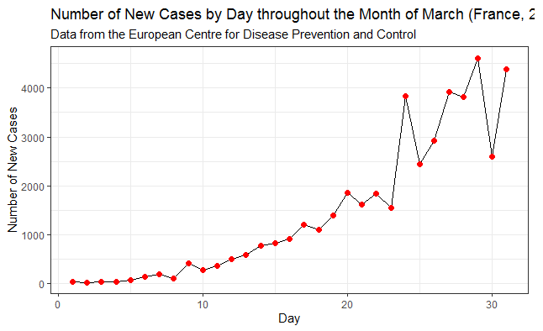

*title = France, 2020)